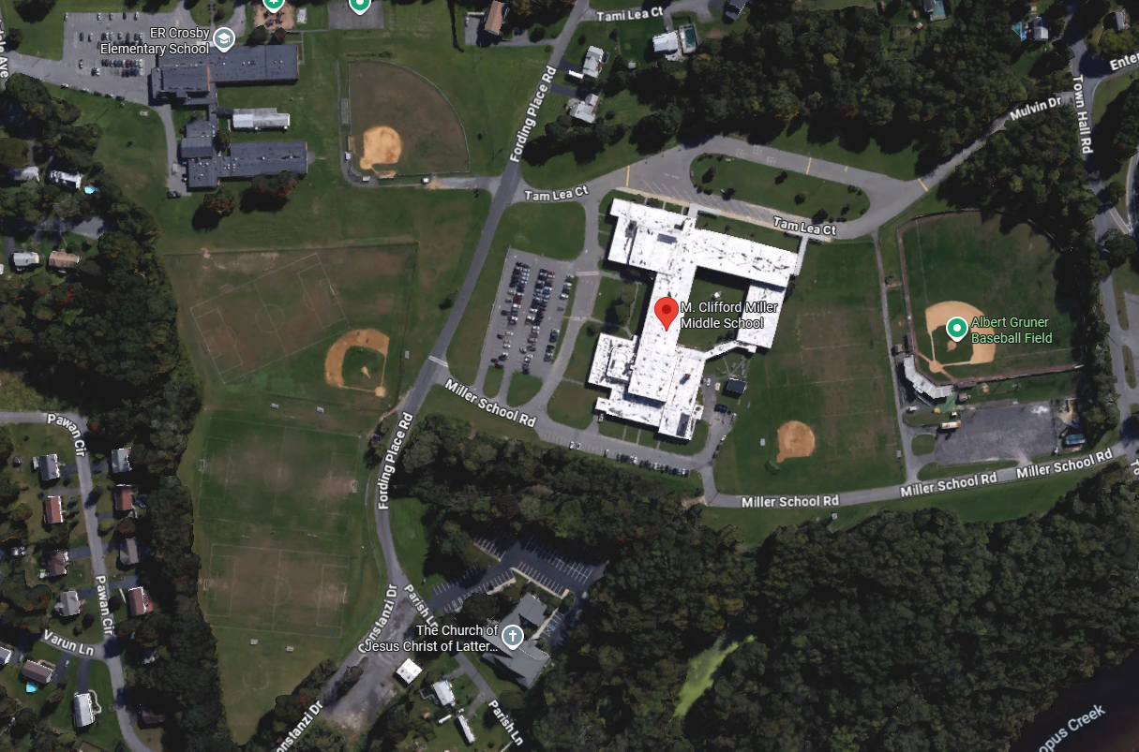
GO AROUND POST EACH TIME
START LINE
FINISH
Kingston Varsity XC Course – 3.0 miles
Mile 1 – GREEN
Mile 2 – BLUE
Mile 3 – ORANGE
2.25 loops – mostly grass, some trail, pavement crossings

