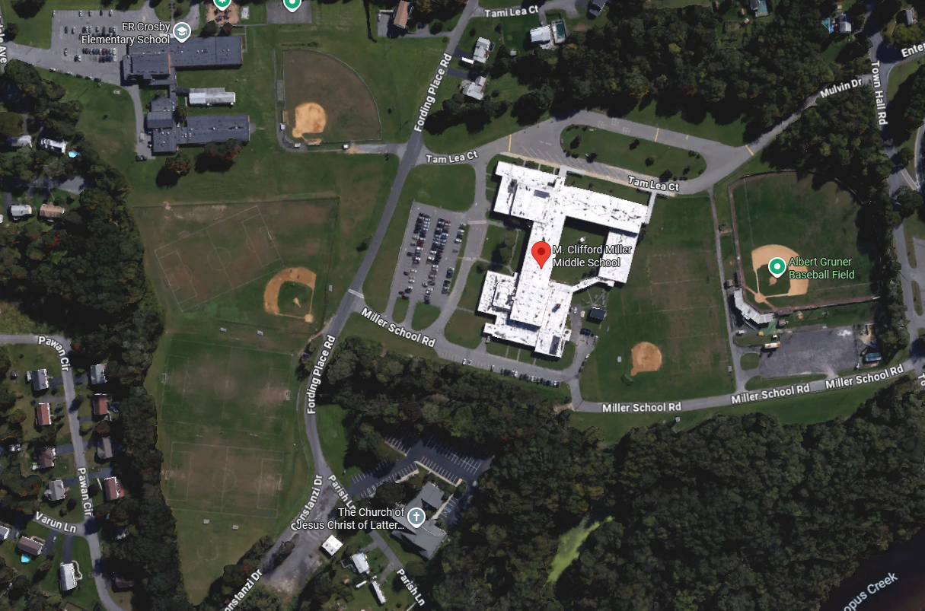
GO AROUND POST EACH TIME
START LINE
FINISH
Kingston Modified XC Course – 1.5 miles
Mile 1 – GREEN
Mile 2 – ORANGE
1.25 loops – mostly grass, some trail, pavement crossings

